# Gizinta Sync Engine Setup

This document provides an overview of the Sync Engine file structure, along with specific instructions for configuring a computer that will be used to process drawings.

### Get zipped folder structure and move to server

You will receive a zip file that contains Sync Engine tools and configuration files. These tools can be unzipped to your local file system as described below.

* + Top level folder will be name c:\apps\gizinta\gse<organization code>
  + Subfolders:
    - **CAD** – note that most of the drawings are often located somewhere else, this generally contain a few drawings for initial testing purposes
    - **Data Models** – Xml Workspace document for Geodatabase, also can store support tables like floor_levels and other datasets useful for setting up the database
    - **Docs** – the location of this file and other documentation.
    - **ETL** – Folder that contains the data loading tools. This folder contains
      * .bat files that are used to run the processing,
      * a gse.py file that is used to map the folder structure for processing
      * a few Geoprocessing toolboxes called gse.tbx (general tools) and gseLocal.tbx (local processing tools specific to a specific site)
      * This folder will also contain a set of FME custom transformers that will need to be set up on each machine where processing will run.

The ETL subfolders are:

* + - * + **config** – Contains Gizinta Xml files that drive the data and field mapping from source to target datasets.
        + **fme** – Contains FME workbench files and associated python and log files
        + **py** – Contains the python scripts used to set up the database, load data, and sync changes between databases
        + **serverConfig** – Contains sde Connection files, and also process-specific configuration settings.
        + **views** – SQL files to create the views and perform some administration tasks

### Setup CAD drawing folder structure

The next step is to set up the folder structure for the drawings. Typically this will be pre-defined, but there are a few basic requirements for the Sync Engine processing. The main dependency is that the SiteID for drawings will be determined by one of the folder names in the file structure.

* Any CAD folder structure can be used, and often the files are located on a different drive from the Sync Engine folders.
* Typically, the folder structure will follow the pattern shown below. Using this approach makes it simple to configure the loading process, but with a few code changes any other structure could be used.
  + Top folder (i.e., CAD)
    - <SiteCode> - the Code value that by default will be the SiteID created in the database
      * Archive – Drawings to be archived. Folder structure is not important but often will be parallel to the Floorplan structure.
      * Floorplans – Floorplan and Outline Drawings. Note that organizing by building beneath this folder is the recommended approach, but all of the drawings can be in a single folder if desired.
        + 0001-Building1 – Building code plus name

0001Outline.dwg – outline drawing

0001_01.dwg – first floor first building

esri_cad.wld or a separate .wld file for both outline and 0001_01 drawings.

* + - * + …
      * Siteplans
        + .dwg files for each siteplan drawing

### Verify and Install software as needed

* ArcGIS Desktop standard+ 10.2+
* FME Desktop 32 bit 2014+ (Esri)
* Database software (SQL Server, PostreSQL, Oracle installed). Version of database software should be a supported esri version.
* ArcGIS Server Enterprise Standard+ 10.2+ - license is required to enable geodatabase storage in the target databases.

### Setup databases

* Create Empty databases for Staging and Production, you will need at least one Staging database per site per spatial reference. You will need to license the database using the Create Enterprise Geodatabase or Enable Enterprise Geodatabase Geoprocessing tools from Esri.
* In ArcCatalog, browse to the serverConfig folder, change the .sde Connection File settings to point to local Staging and Production databases
* Import Xml Workspace to create schema from the Data Models folder
* Set up supporttables.gdb – copy data to production database. You might have scripts to create this table delivered with the project, but these tables make it simpler to just copy/paste data to the target Production database.
  + Active_Floor – must have content to match data that will be created for building and floor IDs.
  + Floor_Level – this is needed for derived floorplan processing to run.

### FME setup

* Set location of fme software in the serverConfig .Xml files. Typically this will be c:\apps\FME\fme.exe but can be different depending on how FME was installed.
* If you have used the C:\Apps\Gizinta\gseXX folder structure the .fmw files will not need to be changed.

### Configuration settings

* 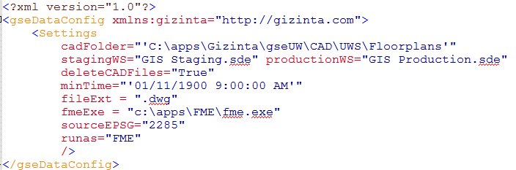The serverConfig .Xml files should be the only files that you will need to change on a specific server. An example for gseDataConfig.xml is shown below:
* The cadFolder must be set to the top level folder to be scanned for drawings. Note that there are extra ‘’ marks around the text since an eval function will be used in the tools to locate the path, and values such as ‘gsePath + \SITE\Floorplans’ can be used. Other desired folder values can be embedded in gse.py to simplify configuration.
* minTime is a setting for the modified date on the files that will be processed. This value will be eval’d in python so any valid time statements can be used to produce a string that uses the following format: "%Y/%m/%d %H/%M/%S %p". An example is time.strftime("%Y/%m/%d %H/%M/%S %p")
* You should not need to change any of the settings below, but a description is included for reference purposes:
  + The stagingWS and productionWS locations should be the names of the .sde connection files in the serverConfig folder.
  + deleteCADFiles can be False or True. This controls the deletion of CAD files after processing completes successfully for each drawing.
  + fileExt controls the file suffix to search for, the default is ‘.dwg’.
  + sourceEPSG is the source coordinate system. This should be set for your project, and it will match the FME EPSG values – which are not always the same as Esri values for the same spatial reference.
  + runas – currently only “FME” is supported.
  + truncate = “Y”/”N” – if this is not present the default is “Y”. “Y” is the normal sync setting but some bulk loading processes may set this option to “N”.

### Setup Geoprocessing Tools, Views

There are several Geoprocessing tools that need to be set up and run.

* + Create views using Create Except Views tool for your database platform. This will create the database views required to sync from Staging to Production. The tool is in the gse.tbx toolbox, and you should have a site-specific Create Views GP model in gseLocal.tbx for your site.
  + Create views using the Create Published Views tool. This will create the Public/Published database views that will exclude Hidden parts of your Facilities. The Sensitivity=’Hidden’ value will be excluded, and this will be set as part of processing the data for your facilities.
  + In gse.tbx, open the Analyze Datasets model and verify it will run – the most likely issue is that a change in database/schema name may have invalidated the model on your systems. This model will be run every 10 drawings and any processing you want to have run on that cycle should be inserted into the model. Test this carefully since processing will stop if it fails to run.

### Database Permissions

This stage may require several steps, and typically organizations have a pre-defined approach for managing database security for editing.

For viewers of the database, the simplest approach is to grant select access to the Published views in ArcGIS desktop on the Production database. If set up correctly, users will be able to see the database and views, but not even see the contents of the Floorplan feature dataset (notice there is no way to view the contents of the feature datasets in the example below.

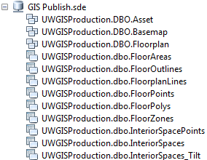

Once this is set up, alter the GIS Publish.sde connection file in the serverConfig folder to use the read-only user name and password to test access to the database.

### Test

* Run the processes
  + BldgOutline_sync.bat – this will create the Building Outline data.
  + Floorplan_sync.bat – this will create the floorplan and derived data.

### Setup Github after initial install/test

* Local changes will be committed and sync’d to Github
* Updates to be distributed via Github
* You will receive more specific instructions on the Github setup once your system has been set up.